**Design Document**

Clare Oliver

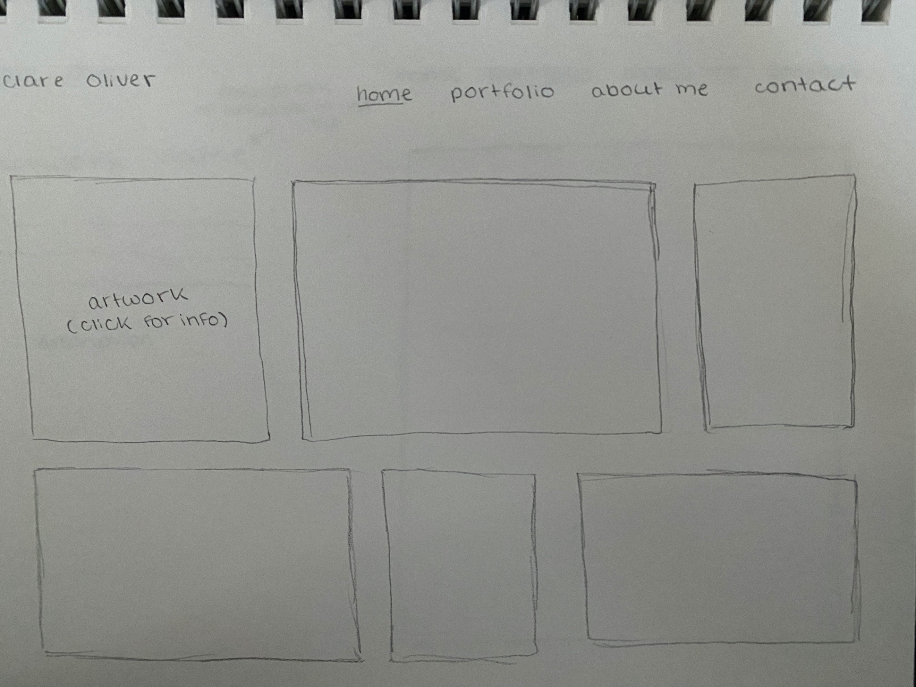

**Home**

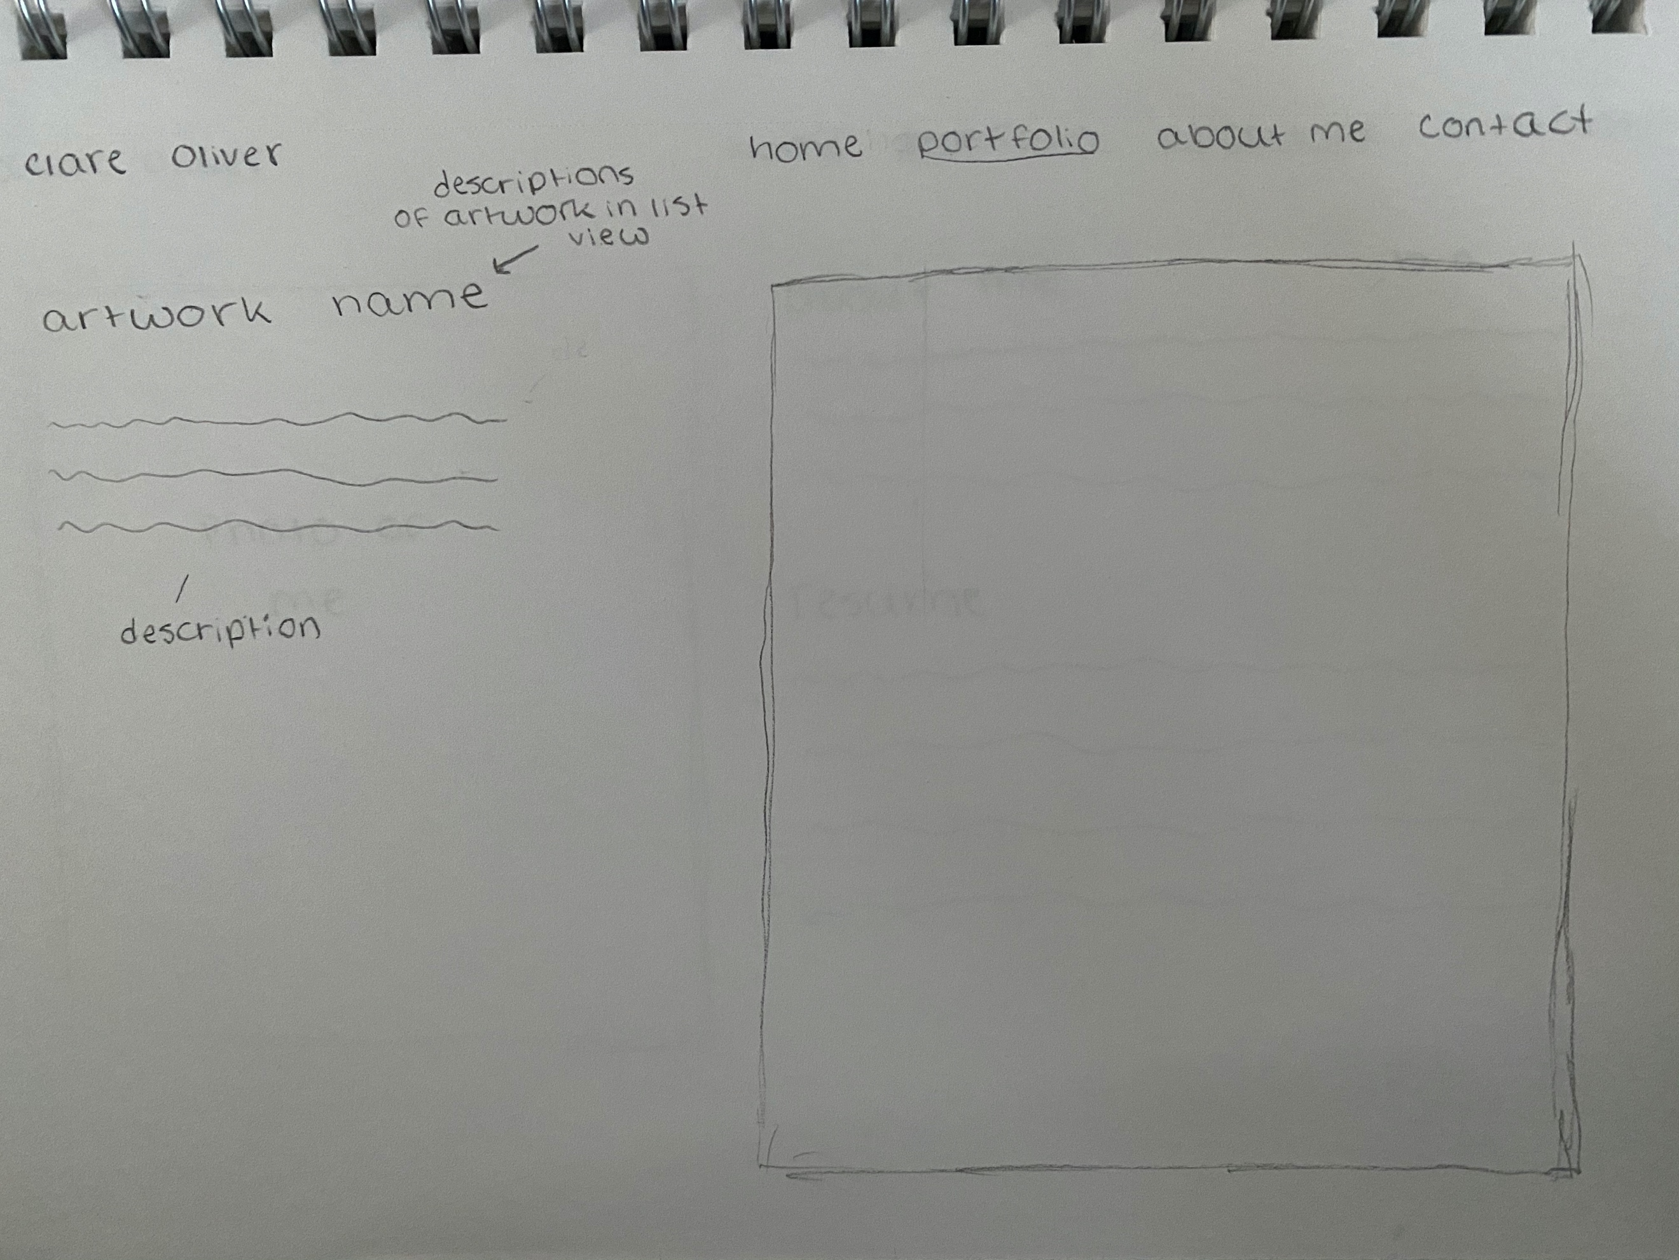

**Portfolio**

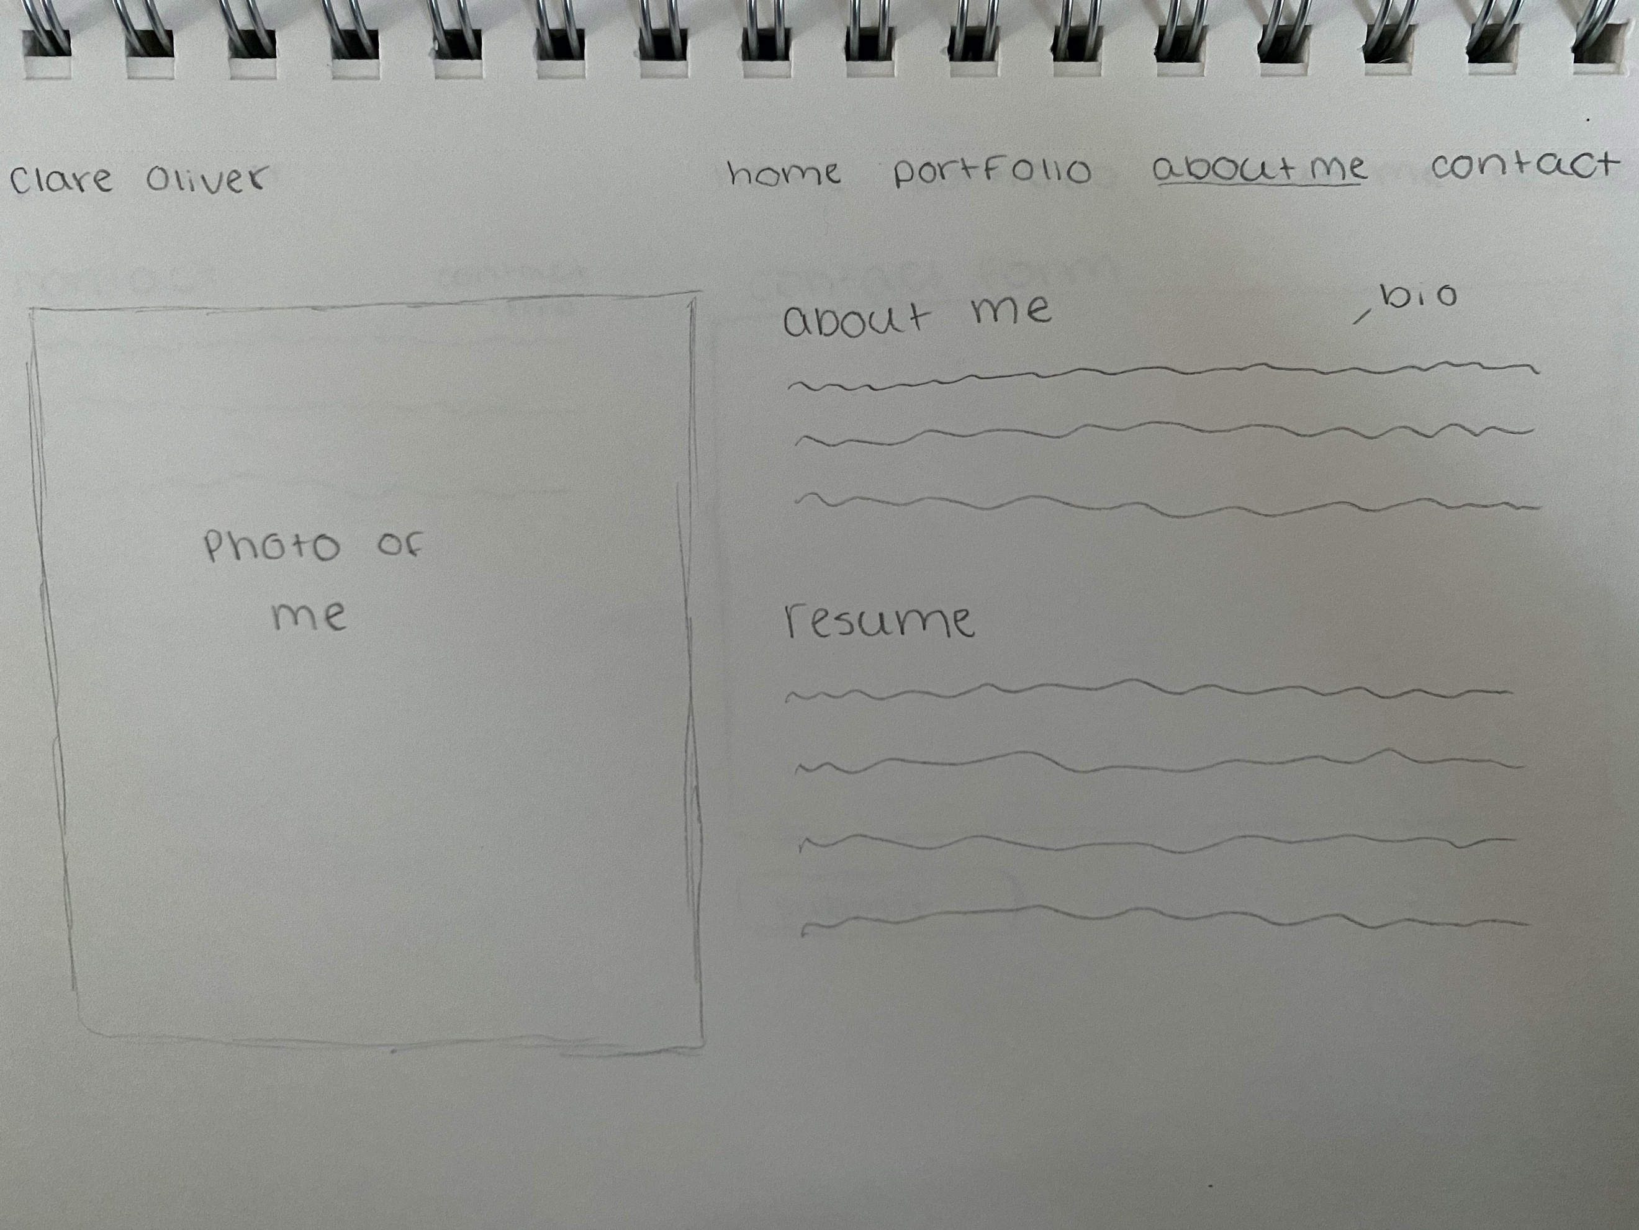**About Me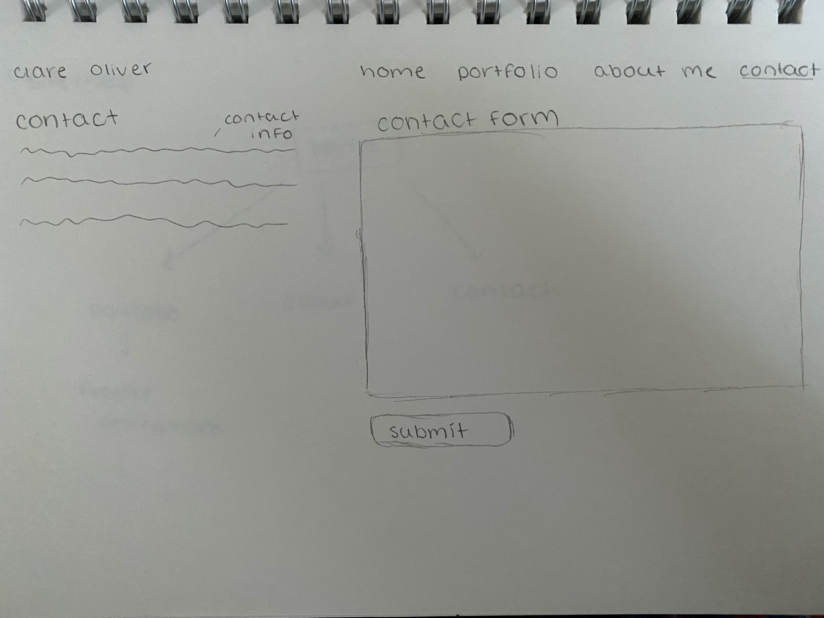Contact**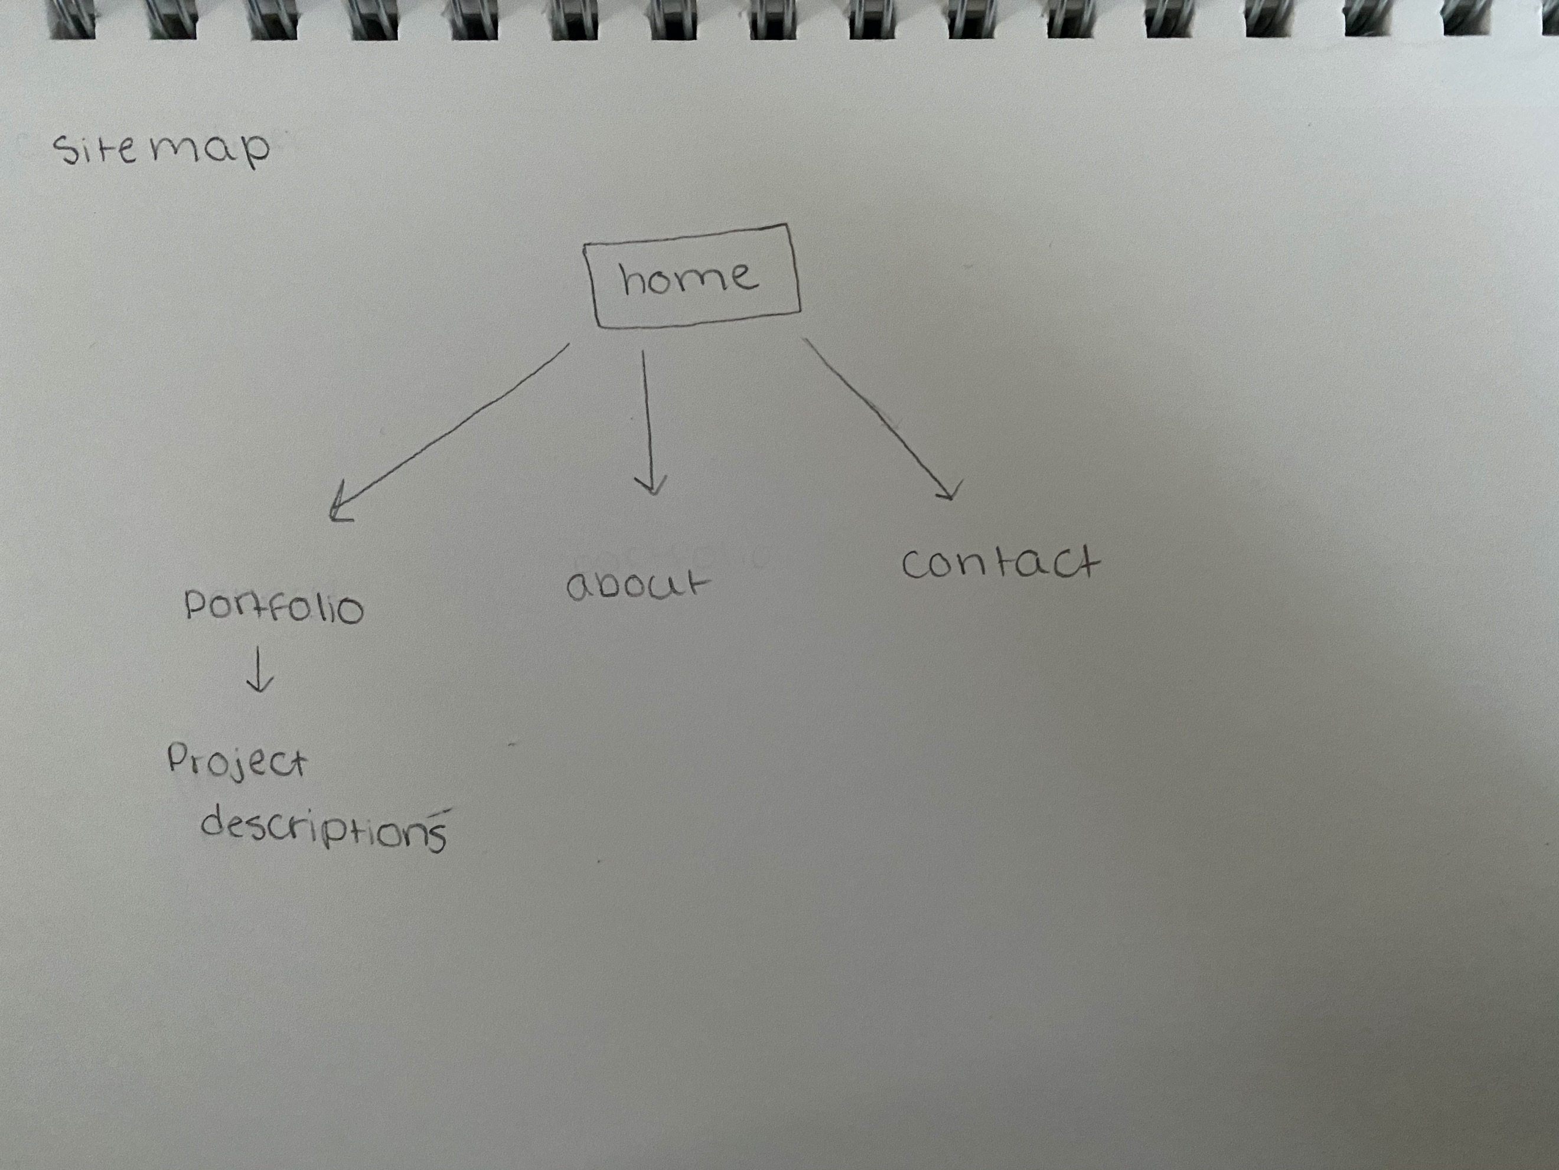

**Site Map**

**Colors:**

I decided to only use one accent color because the focus of the site is the designs I’m displaying, which will already be many different colors

* Black- for all of the text on the site
* White- for the background
* Pink- #CD428C Accent color, used in the nav bar and maybe titles of pages

